Title of the Project

Software Engineering Course Project (CS-303)
BS(CS) Spring 2018

M.Ibrahim Jawed
K15-2131

Taha Asif
K15-2855

Shahiq Qureshi
K15-2822


Supervisor: Miss Javeria

<Co-supervisor (if any): Co-Supervisor Name and Signature>

Department of Computer Science

FAST-National University of Computer & Emerging Sciences, Karachi.

Abstract

This project is about the E-Voting system. E-Voting system provides voters easiness in terms of voting. This project is about giving access to voters to vote via online system. The voters can vote from voters own android phone while at staying at home. This project removes the trouble of rush that voters get on Election Day at polling stations. Rather than going to polling station and creating rush and haphazard situation at polling station, the voters can now vote his political representative using his android phone.
Moreover, this project can be used during universities and school voting activity. In school, the nomination of head boy and deputy head boy can be done easily via this project. Furthermore, this project can help in universities to elect any head or deputy of any society.

- Introduction
The day of elections in any country is a very busy day. Voters visit to polling stations and cast their vote to their political representative. This procedure of casting votes can be tremendously very difficult to handle. Handling of this procedure is difficult due to the population of the country where elections are going to be held. Handling of the law and order situation on day of election is already a muddle.
Also within institutions it is a very complicated procedure to select the head of any society. E-Voting System will provide facility to voters to select the head of society demanded by user.
Therefore, the purpose of E-Voting System is to minimize the human efforts on the day of election (within institution or country). Moreover, the votes casting effort and votes counting effort would be saved. The voters now do not need to go to polling stations and creating a rush at polling station. They can now use their own android phones to cast votes. Furthermore, the chance of rigging in elections is minimized.

- OVERVIEW
  - Significance of the Project
The main challenging area in this project is the construction of safe database system because it’s the matter of proper and fair voting system.
  - Description of the Project
The problem of rigging in the elections can be eliminated by a safe E-Voting System. Also, due to population rise, it has become a nightmare to conduct a fair election without disturbing the law and order situation in the country. Therefore, the main objective of the project is to give voter’s access to vote from voter’s own place.
  - Background of the Project
The mess up conditions on the day of election has become a usual habit in poor countries. From the record of past 10 years, we can see complains of rigging in the elections in Pakistan. In order to overcome these problems, E-Voting System has been introduced.
  - Project Category
E-Voting System is the product based android application.
- METHODOLOGY
The project is be divided into four major phases as follow;
  - Design phase
The e-voting system is an android phone based system. So first we will define the requirements than we will identify the classes the interfaces required and design the UML models.
  - Implementation phase
The implementation can be broken down into the following steps:
- Implementing core requirements like database (firebase if feasible), android application initials and admin panel web page.
- The basic features such as essential tables, core features of admin panel and basic user side features will then be added.
- Testing of the core features.
- Than the less important features will be implemented.

  - Testing phase
For testing, the core features, after implementation, will be tested. Once they are clear than development of less crucial features will take place. Than the final product will be tested.
  - Evaluation phase
For evaluation we will give a demonstration.

- FEATURES
- Maintenance of Database System
- Automated Registration System
- Email Notification
- Amazing UI (Graphical User Interface)
- Better UX ( User Experience)
- Settings Panel
- Online Candidates registration
- CNIC and password checker
- Mobile Number Validator
- SMS Notification
- Android Notification
- Better with logout activity
- Safe Vote Casting
- Encrypted database with SHA1 encryption
- Events and other Elections notifier
- Automated Events and triggers in database
- Automated database backup for safety precautions
- Secured Admin Panel
- Candidates Registration at Admin Panel
- Automatic Session (Shared Preference) Saving in Android

SYSTEM ARCHITECTURE
Android Application:
E-Voting Android Application can be used on android phones having Android versions greater than 4.1(Jelly Beans).
Application Server:
Application Server will be on Local Host where all the Admin credentials and controls will reside.
Database Server:
Database Server will be used to store the information related to the application.
API:
This project is expected to utilize built-in API’s to produce a Smart E-Voting app.
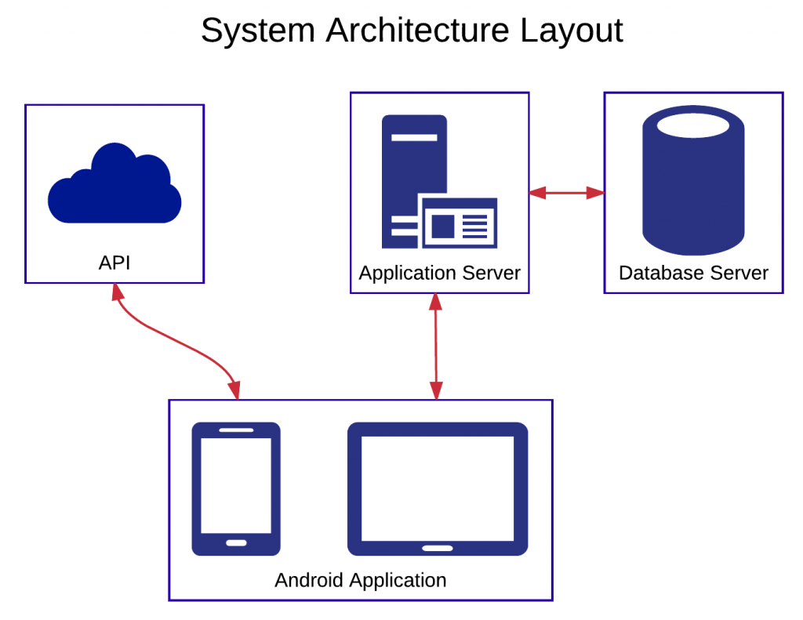

- PROJECT DILIVERABLES
An Android Application for E-Voting will be delivered at the end. Android Application will be delivered by using Java and Android Studio.
- PROJECT DILIVERABLES
An Android Application for E-Voting will be delivered at the end. Android Application will be delivered by using Java and Android Studio.

- REFERENCES
https://www.epimorphics.com/student-project-myrivers-intro/

